**Ex: No: E-BOOK MANAGEMENT SYSTEM**

**Date:**

**AIM:**

To Design, Implement and Test the E-book management system described in the given problem statement.

**PROBLEM STATEMENT:**

E-book process is well organized online buying and selling of books. This system is well developed in various resources, for example Amazon deals with more e-booking concept. This process has various issues in basics of maintenance of database and updating in sites and virus problem in PDF books, so we have many issues in this process. the process of e-books is fully based on online, and the process for this mainly interaction between the buyer and seller, buyer who enter the site for purchase of book will use the search engine for the books to purchase, the search engine will be mainly focused on database process, it is used to search book for buyer who mentioned the book name, author name, edition, publication details in the site, so that the search engine will many books. There will be a payment option and option for PDF file or hardcopy deliver to home, user should decide whether to select which one. Whether his choice hardcopy means full detail address, delivery license number and then he should login with his username and password, and then payment through ATM debit or credit card applicable.

**USECASE DIAGRAM:**



**CLASS DIAGRAM:**



**SEQUENCE DIAGRAM:**



**ACTIVITY DIAGRAM:**



**STATE CHART DIAGRAM:**



**COMPONENT DIAGRAM:**

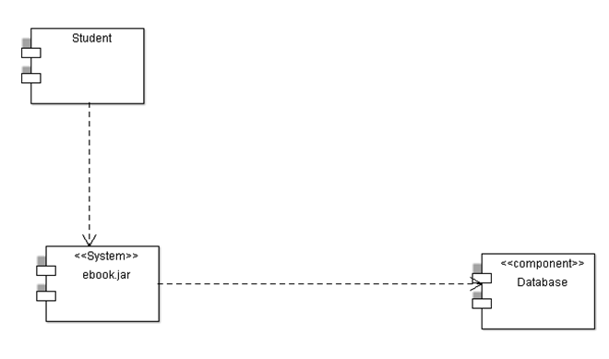

**DEPLOYMENT DIAGRAM:**

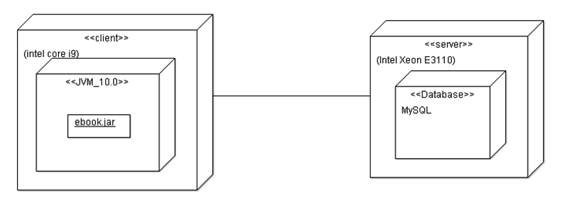

**IMPLEMENTATION & TESTING**

**Admin.java**

package eBook;

import java.util.Scanner;

import java.io.*;

class Admin extends Book

{

public void operation()

{

int a;

do

{

System.out.println("select an option");

System.out.println("1.Admin login\t2.Member login\t3.exit");

Scanner s=new Scanner(System.in);

int m=s.nextInt();

switch(m)

{

case 1:

{

Book p=new Book();

p.managebook();

break;

}

case 2:

{

Member c=new Member();

c.order();

break;

}

case 3:

System.exit(0);

}

System.out.println("enter 1 to continue to select login");

a=s.nextInt();

}while(a==1);

}

}

**Book.java**

package eBook;

import java.util.*;

import java.io.*;

class Book extends Member

{

int t;int f;int i=0;int count=0,count1=0;

public static int[] bid=new int[100];

public static String[] bname=new String[100];

public static int[] qty=new int[100];

public static int[] ord=new int[100];

public void managebook()

{

Scanner s=new Scanner(System.in);

do

{

System.out.println("1.Add\n 2.display\n 3.delete\n 4.update\n");

System.out.println("enter the option");

int n=s.nextInt();

switch(n)

{

case 1:

System.out.println("enter the number of Books to be added");

int no=s.nextInt();

System.out.println("enter the id,name,qty of the Book");

no=no-1;

int f=i+no;

for(;i<=f;i++)

{

bid[i]=s.nextInt();

bname[i]=s.next();

qty[i]=s.nextInt();

}

i=i;

System.out.println("Books added successfully");

break;

case 2:

System.out.println("enter the number of Books to be printed");

int scan=s.nextInt();

for(int i=0;i<scan;i++)

{

System.out.println("B_id B_name qty ");

System.out.println(bid[i]+"\t"+bname[i]+"\t"+qty[i]);

}

System.out.println("The Books informations are displayed");

break;

case 3:

System.out.println("enter the id of the Book to be deleted");

int did=s.nextInt();

for(int i=0;i<=bid.length-1;i++)

{

if(bid[i]!=0)

{

count++;

}

}

for(i=0;i<=count+1;i++)

{

if(bid[i]==did)

{

bid[i]=bid[count-1];

bname[i]=bname[count-1];

qty[i]=qty[count-1];

bid[count-1]=bid[bid.length-1];

bname[count-1]=bname[bname.length-1];

qty[count-1]=qty[qty.length-1];

break;

}

}

System.out.println("Boook is successfully deleted");

break;

case 4:

System.out.println("enter the id,name,qty of the Book to be added");

int nid=s.nextInt();

String nname=s.next();

int nqty=s.nextInt();

for(int i=0;i<=bid.length;i++)

{

if(bid[i]==nid)

{

bid[i]=nid;

bname[i]=nname;

qty[i]=nqty;

break;

}

}

System.out.println("Book is updated successfully");

break;

case 5:

System.exit(0);

}

System.out.println("enter 1 to continue to manage Books");

t=s.nextInt();

}while(t==1);

}

public static void main(String args[])

{

Admin sp=new Admin();

sp.operation();

}

public void delete(int n)

{

int did=n;

for(int i=0;i<=bid.length-1;i++)

{

if(i!=0)

{

count1++;

}

}

for(int i=0;i<=count1;i++)

{

if(bid[i]==did)

{

qty[i]=qty[count1];

break;

}

}

}

}

**Member.java**

package eBook;

import java.util.*;

import java.io.*;

class Member

{

public void order()

{

Scanner s=new Scanner(System.in);

Book p=new Book();

System.out.println("enter the Book id to be ordered");

int search=s.nextInt();

p.delete(search);

System.out.println("Book ordered successfully");

System.out.println("Enter 1to make payment");

int b=s.nextInt();

if(b==1)

{

Member c=new Member();

c.makepayment();

}

}

public void makepayment()

{

System.out.println("payment successfull");

}

}

**OUTPUT:**

Select an option

1. Admin login 2.Member login 3.exit

1

1.Add

2.display

3.delete

4.update

enter the option

1

enter the number of items to be added

3

enter the id, name, qty of the product to be added

1

HarryPotter

3

2

DaVinciCode

4

3

TheAlchimist

5

Items added successfully

enter 1 to continue to manage product

2

enter 1 to continue to select login

1

select an option

1. Admin login 2.Member login 3.exit

1

1.Add

2.display

3.delete

4.update

enter the option

2

enter the number of items to be printed

3

pid pname qty

1 HarryPotter 3

pid pname qty

2 DaVinciCode 4

pid pname qty

3 TheAlchimist 5

the product information is displayed

enter 1 to continue to manage product

1

1.Add

2.display

3.delete

4.update

enter the option

3

enter the id of the product to be deleted

1

product is successfully deleted

enter 1 to continue to manage product

1

1.Add

2.display

3.delete

4.update

enter the option

4

enter the id , name , qty of the product to be added

2

HarryPotter

2

product is updated successfully

enter 1 to continue to manage product

1

1.Add

2.display

3.delete

4.update

enter the option

2

enter the number of items to be printed

2

pid pname qty

3 TheAlchimist 5

pid pname qty

2 HarryPotter 2

the product information is displayed

enter 1 to continue to manage product

1

1.Add

2.display

3.delete

4.update

enter the option

1

enter the number of items to be added

1

enter the id , name , qty of the product to be added

1

DaVinciCode

6

items added successfully

enter 1 to continue to manage product

0

enter 1 to continue to select login

1

select an option

1.Admin login 2.Member login 3.exit

2

enter the product id to be ordered

1

item ordered successfully

enter 1to make payment

1

payment successfull

enter 1 to continue to select login

1

select an option

1.Admin login 2.Member login 3.exit

1

1.Add

2.display

3.delete

4.update

enter the option

2

enter the number of items to be printed

2

pid pname qty

1 DaVinciCode 0

pid pname qty

2 HarryPotter 2

the product information is displayed

enter 1 to continue to manage product

1

enter 1 to select login

select an option

1.Admin login 2.Member login 3.exit

3

Build successfull...

**TEST REPORT 1**

**Product : E-Book management System**

**Use Case :manage e-book**

|  |  |  |  |  |
| --- | --- | --- | --- | --- |
| **Test Case ID** | **Test Case / Action To Perform** | **Expected Result** | **Actual Result** | **Pass/Fail** |
| 1. 1 | After Entering the Book id,name,qty | Displays ”Books added successfully” | Books added successfully | Pass |
|  | After Entering the Book ID to be deleted | Displays “book is successfully deleted” | Book is successfully deleted | Pass |

**TEST REPORT 2**

**Product : E-Book management System**

**Use Case : manage e-book**

|  |  |  |  |  |
| --- | --- | --- | --- | --- |
| **Test Case ID** | **Test Case / Action To Perform** | **Expected Result** | **Actual Result** | **Pass/Fail** |
|  | After selecting “add” option | Displays “Enter the number of books to be added” | Enter the number of books to be added.  3 | Pass |
|  | After selecting “update” option | Displays “Enter the id,name,qty” of the book to be updated | Enter the id,name,qty of the book to be updated.  3  DaVinciCode  7 | Pass |

**TEST REPORT 3**

**Product : E-Book management System**

**Use Case : Make Payment**

|  |  |  |  |  |
| --- | --- | --- | --- | --- |
| **Test Case ID** | **Test Case / Action To Perform** | **Expected Result** | **Actual Result** | **Pass/Fail** |
|  | After books ordered successfully | Displays “Enter 1 to make payment” | Enter 1 to make payment | Pass |
|  | After Entering ‘1’ to make payment | Displays “Payment successful” | Payment successful | Pass |